To be added in R&C Webpage in About before Vision
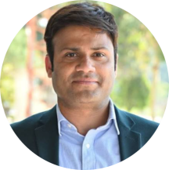 | Prof. (Dr.) Nabeel Ahmad  Director (Research)  director.research@srmu.ac.in
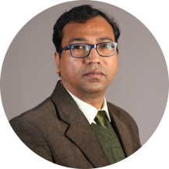 | Prof. (Dr.) Alkesh Agrawal  Deputy Director (Research)  dd.research@srmu.ac.in
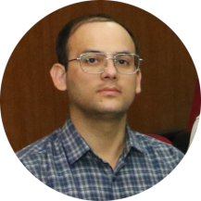 | Dr. Shailendra Bisht  Asstt. Registrar (Research)  research@srmu.ac.in

